# Log In

1. User inserts card

Login screen appears:

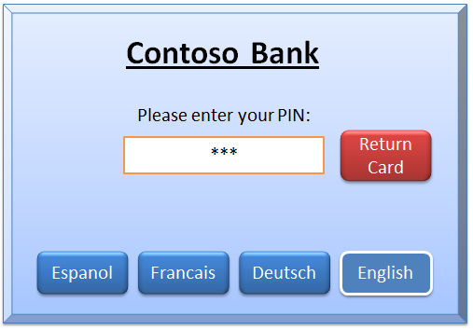

1. User can select language.

This persists for the session.

1. User enters PIN

If verified, login is complete.

* If not verified, displays “Please re-enter – *n* tries left”

User can press Return Card at any time.

Number of retries is limited to 3 per day.

# Select Transaction

1. Select transaction screen appears:

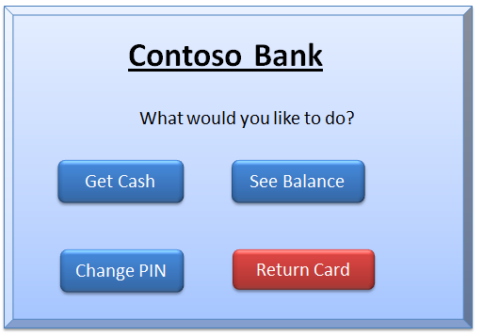

1. User presses one

* Balance is available only for home customers.  
  Balance button does not appear for other customers.

# Get Cash

1. Get cash screen appears:

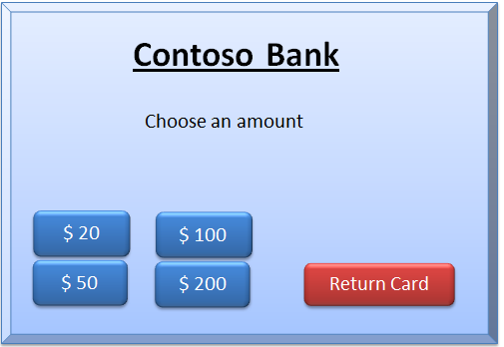

1. User chooses amount.

Some values might be unavailable depending on stocks of notes.

The buttons for unavailable options are hidden. Other buttons remain in the same positions.

No button overlaps with the position of the Get Cash button.